Jason Reinoso

12/12/16

Et 501 TP

Pc gaming, and their advantages over consoles

Right now video games play a huge part in people’s lives, especially those around who are 20 years old and below, and people who make money off video gaming such as youtubers, and Esports. No matter the age, however there are different ways to play video games, which are consoles and PC (personal computers). Consoles include Xbox, and PlayStation which are primarily about gaming, but can include features such as streaming movies, or voice chat with your friends, however that’s all they can really do. Consoles limit players of many things from the quality of the game their playing, or internet services. Pc doesn’t have that ceiling, in fact players even have the ability to mess with the game, scrambling code around to make modifications (mods) to make the game even better. Pc gaming superior to consoles for many reasons, one example is internet services. For Pc gaming, one can use multiple networks to get their games such as Steam or Uplay. These networks let players buy games, and also saves the information that they brought it, so in a later time if players get a new computer or delete the game files, they are able to reinstall back. Also these networks let players play online for free, letting gamers freely enjoy playing with their friends. Consoles like Xbox, and PlayStation don’t have this feature, and require players to pay a fee, which is $60 per year for Xbox and $50 for PlayStation. Not paying these fees lock features of the console, and various video games.

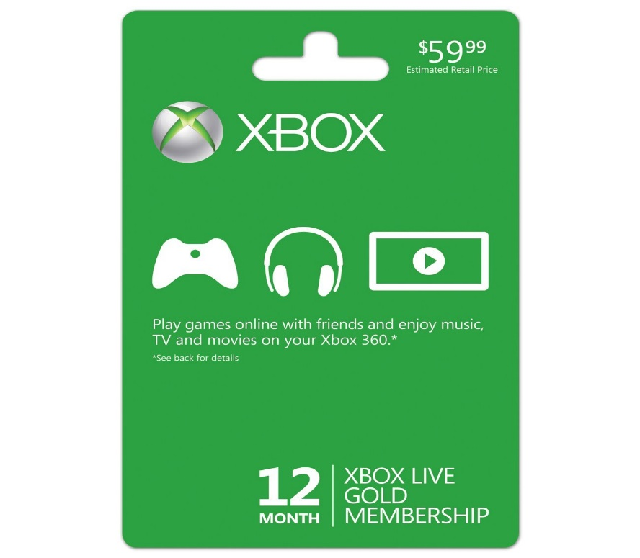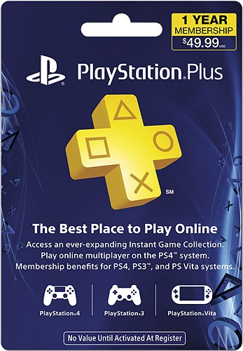

As shown in the pictures above not paying these fees, limit players by denying them certain services such as online multiplayer, Playing music, TV, movies and much more. Secondly one can upgrade Pc, just by buying new parts to meet criteria of new videogames. Even though it’s little pricey it’s very worth it, as it impacts the quality of the game. Gamers are able to upgrade any part such as graphics card, the Cpu, or hard drive. By upgrading parts, one can be able to the game run better, improve the appearance of the game, and store more video games. For consoles, players are again limited, as they can only change the hard drive. Attempting to change any other hardware such as the graphics card can lead to consoles breaking down, or games not being read properly. This leaves player locked, and unable to upgrade consoles to affect gameplay. If a player does want to “upgrade” they must wait for a new console to be made, and once the new console is brought, it makes the old console obsolete.

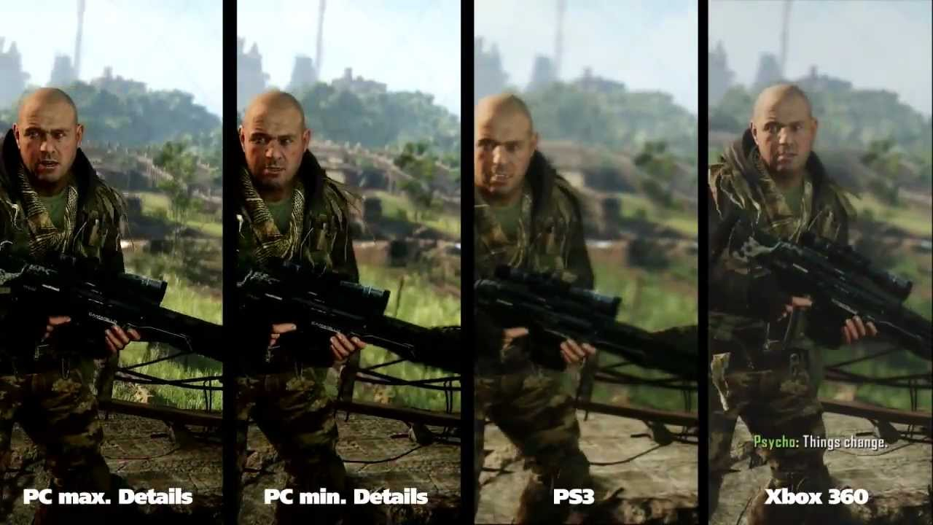

As shown in the picture above, graphics of consoles show blurriness, especially in the background, and bad textures on the character. However on PC, even on the minimal settings it still outperformance consoles. On max settings the video game looks crystal clear, with clear textures, and background. Also as a bonus for PC, they are able to customize the video settings for games, if a player feels that they want performance instead of graphics (appearance) and vice versa. Consoles do not have this, as they are locked in a specific video settings. Lastly PC gamers also have access to sales, where many video games on networks like steam, have discounts for up to 75%. This is a great way to save money, and with so many discounts, gamers are able to buy so many video games. On the other hand consoles do have discounts for games, and even Xbox gives free game. However this is only available if the player paid the membership fee. If not paid, gamers are denied discounts, until the fee is paid, giving a feeling of restrictions to players. Playing on PC is much better than consoles because one does not need to pay any “fees” to play a feature of the game they just brought, discounts up to 75% and also PC is upgradable. In conclusion Consoles will never catch up to PC, and will always remain 2nd best in the gaming community.